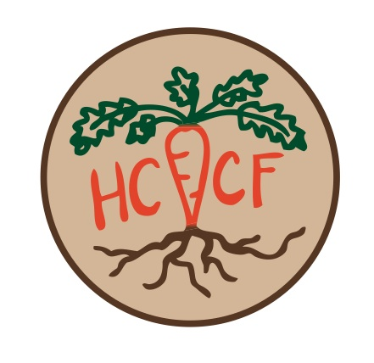 | Catalogue
Item | Description | Price
Beets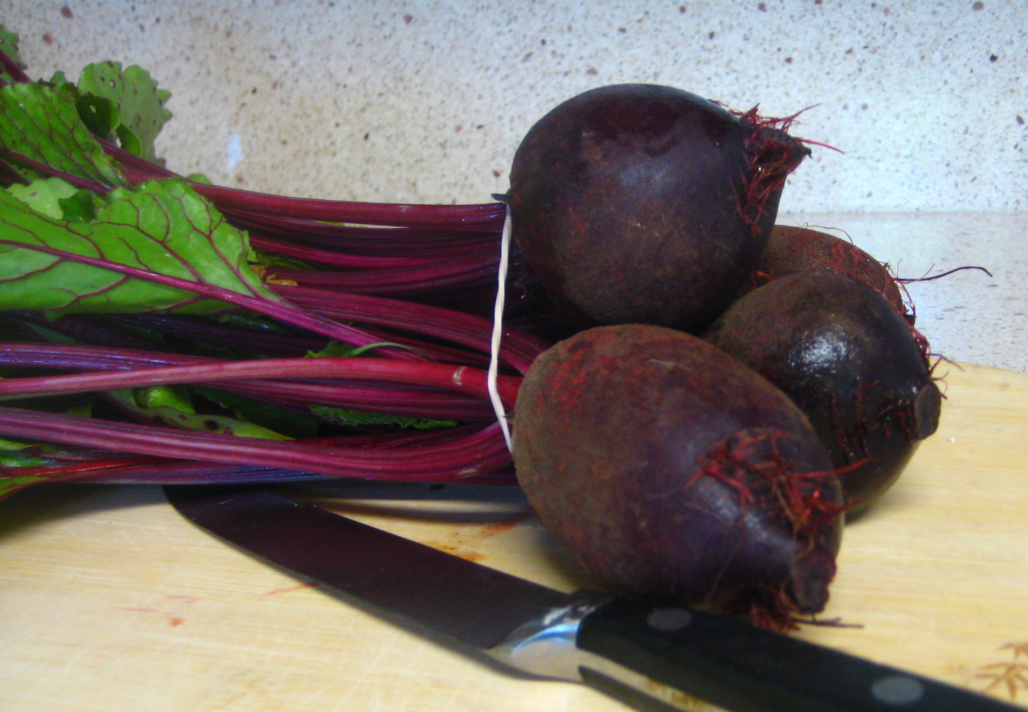 | Dark red flesh is sweet, crisp and tender. Delicious roasted. | $2.50/bunch
Beet, Chioggia | Uniquely beautiful flesh has alternating red and white concentric rings. Very tender. | $2.50/bunch
Chard, Multicolored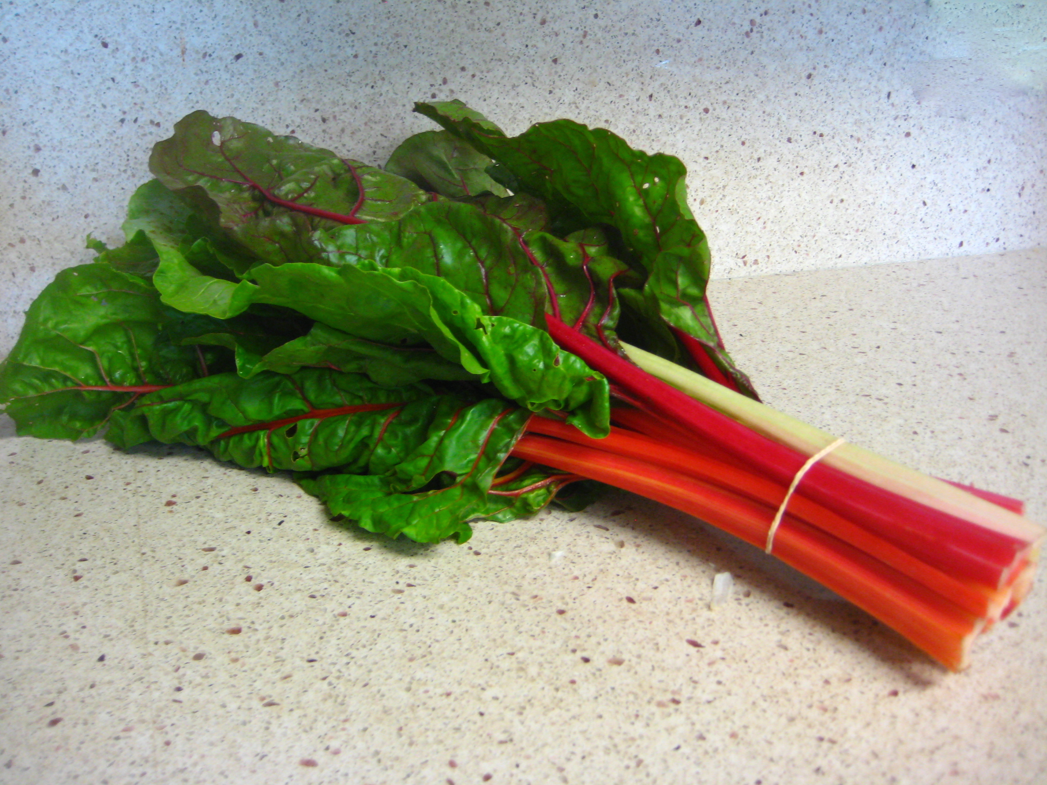 | Slightly bitter taste which fades with cooking, leaving a refined flavor that is more delicate than that of cooked spinach. | $2.50/bunch or 2 for $4.00
Chives | Leaves or lavender flowers can be used to dress up soups and salads for a slightly spicy garnish. Also works well for freezing and drying. | $1.50/bunch
Cauliflower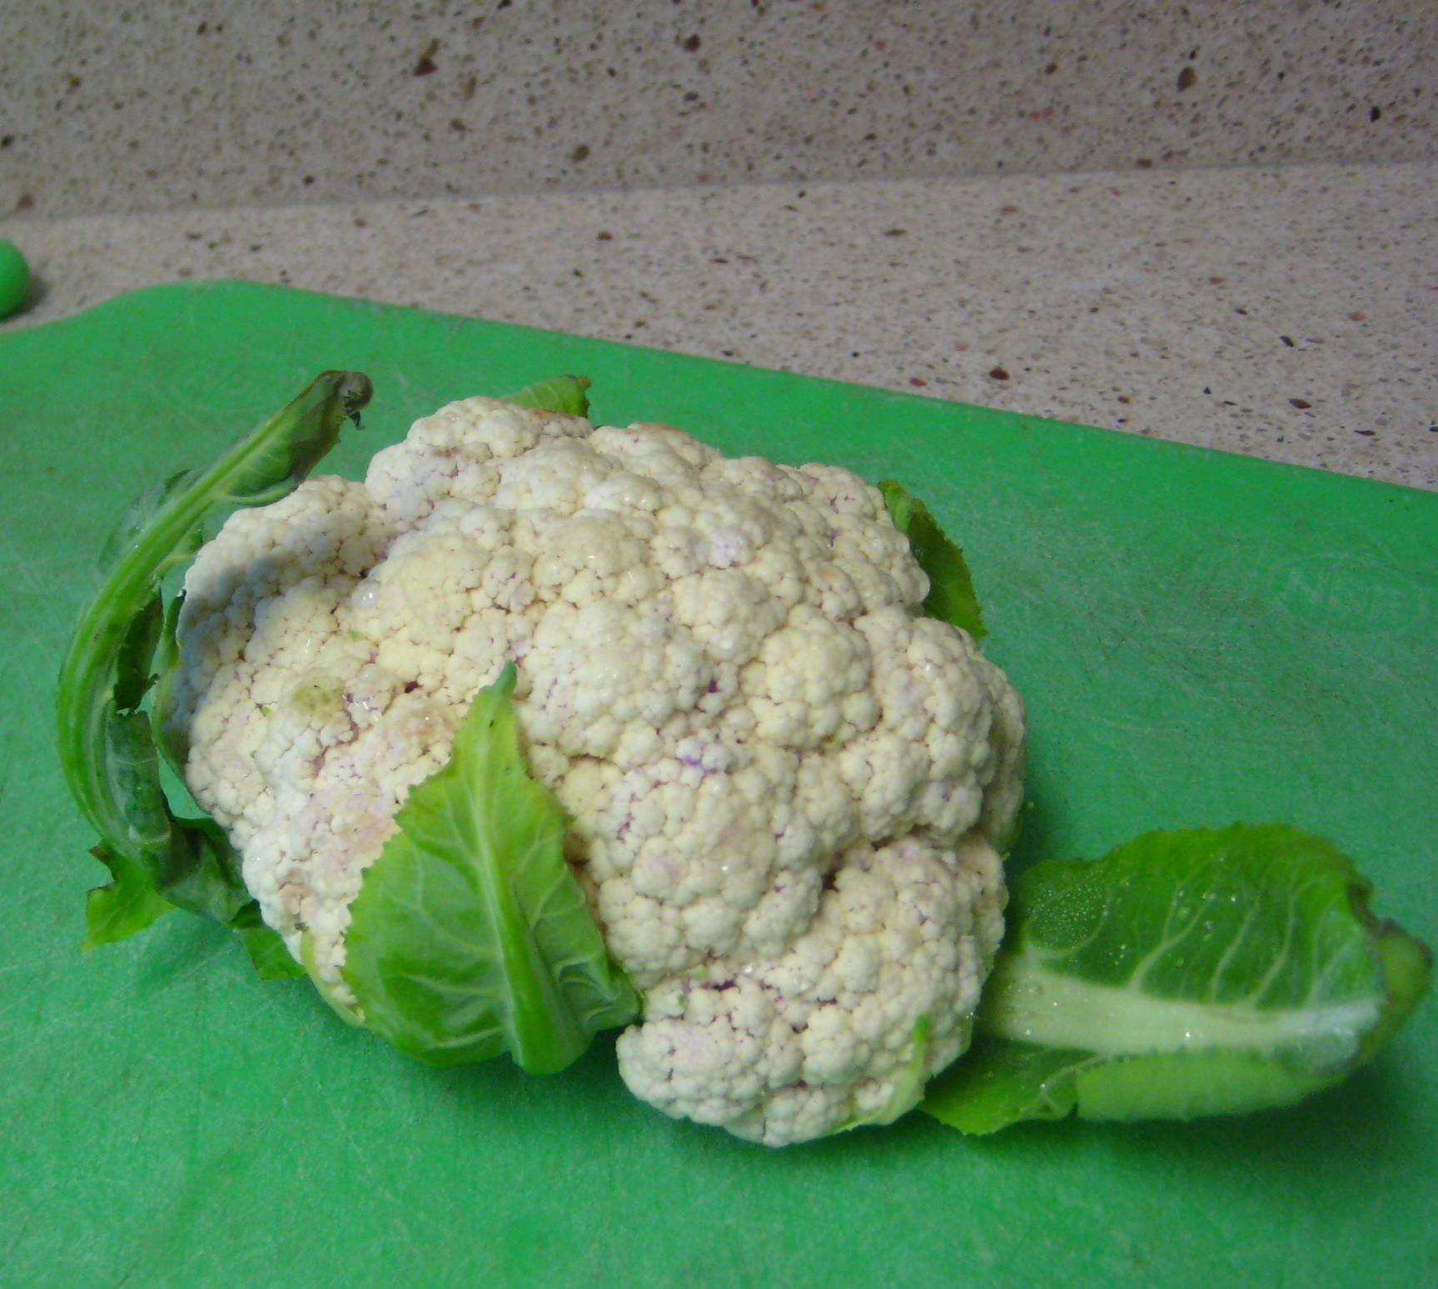 | Small but nice. Smooth heads of tightly formed white curds are solid, crisp and tender. | $2.00/head
Garlic Scapes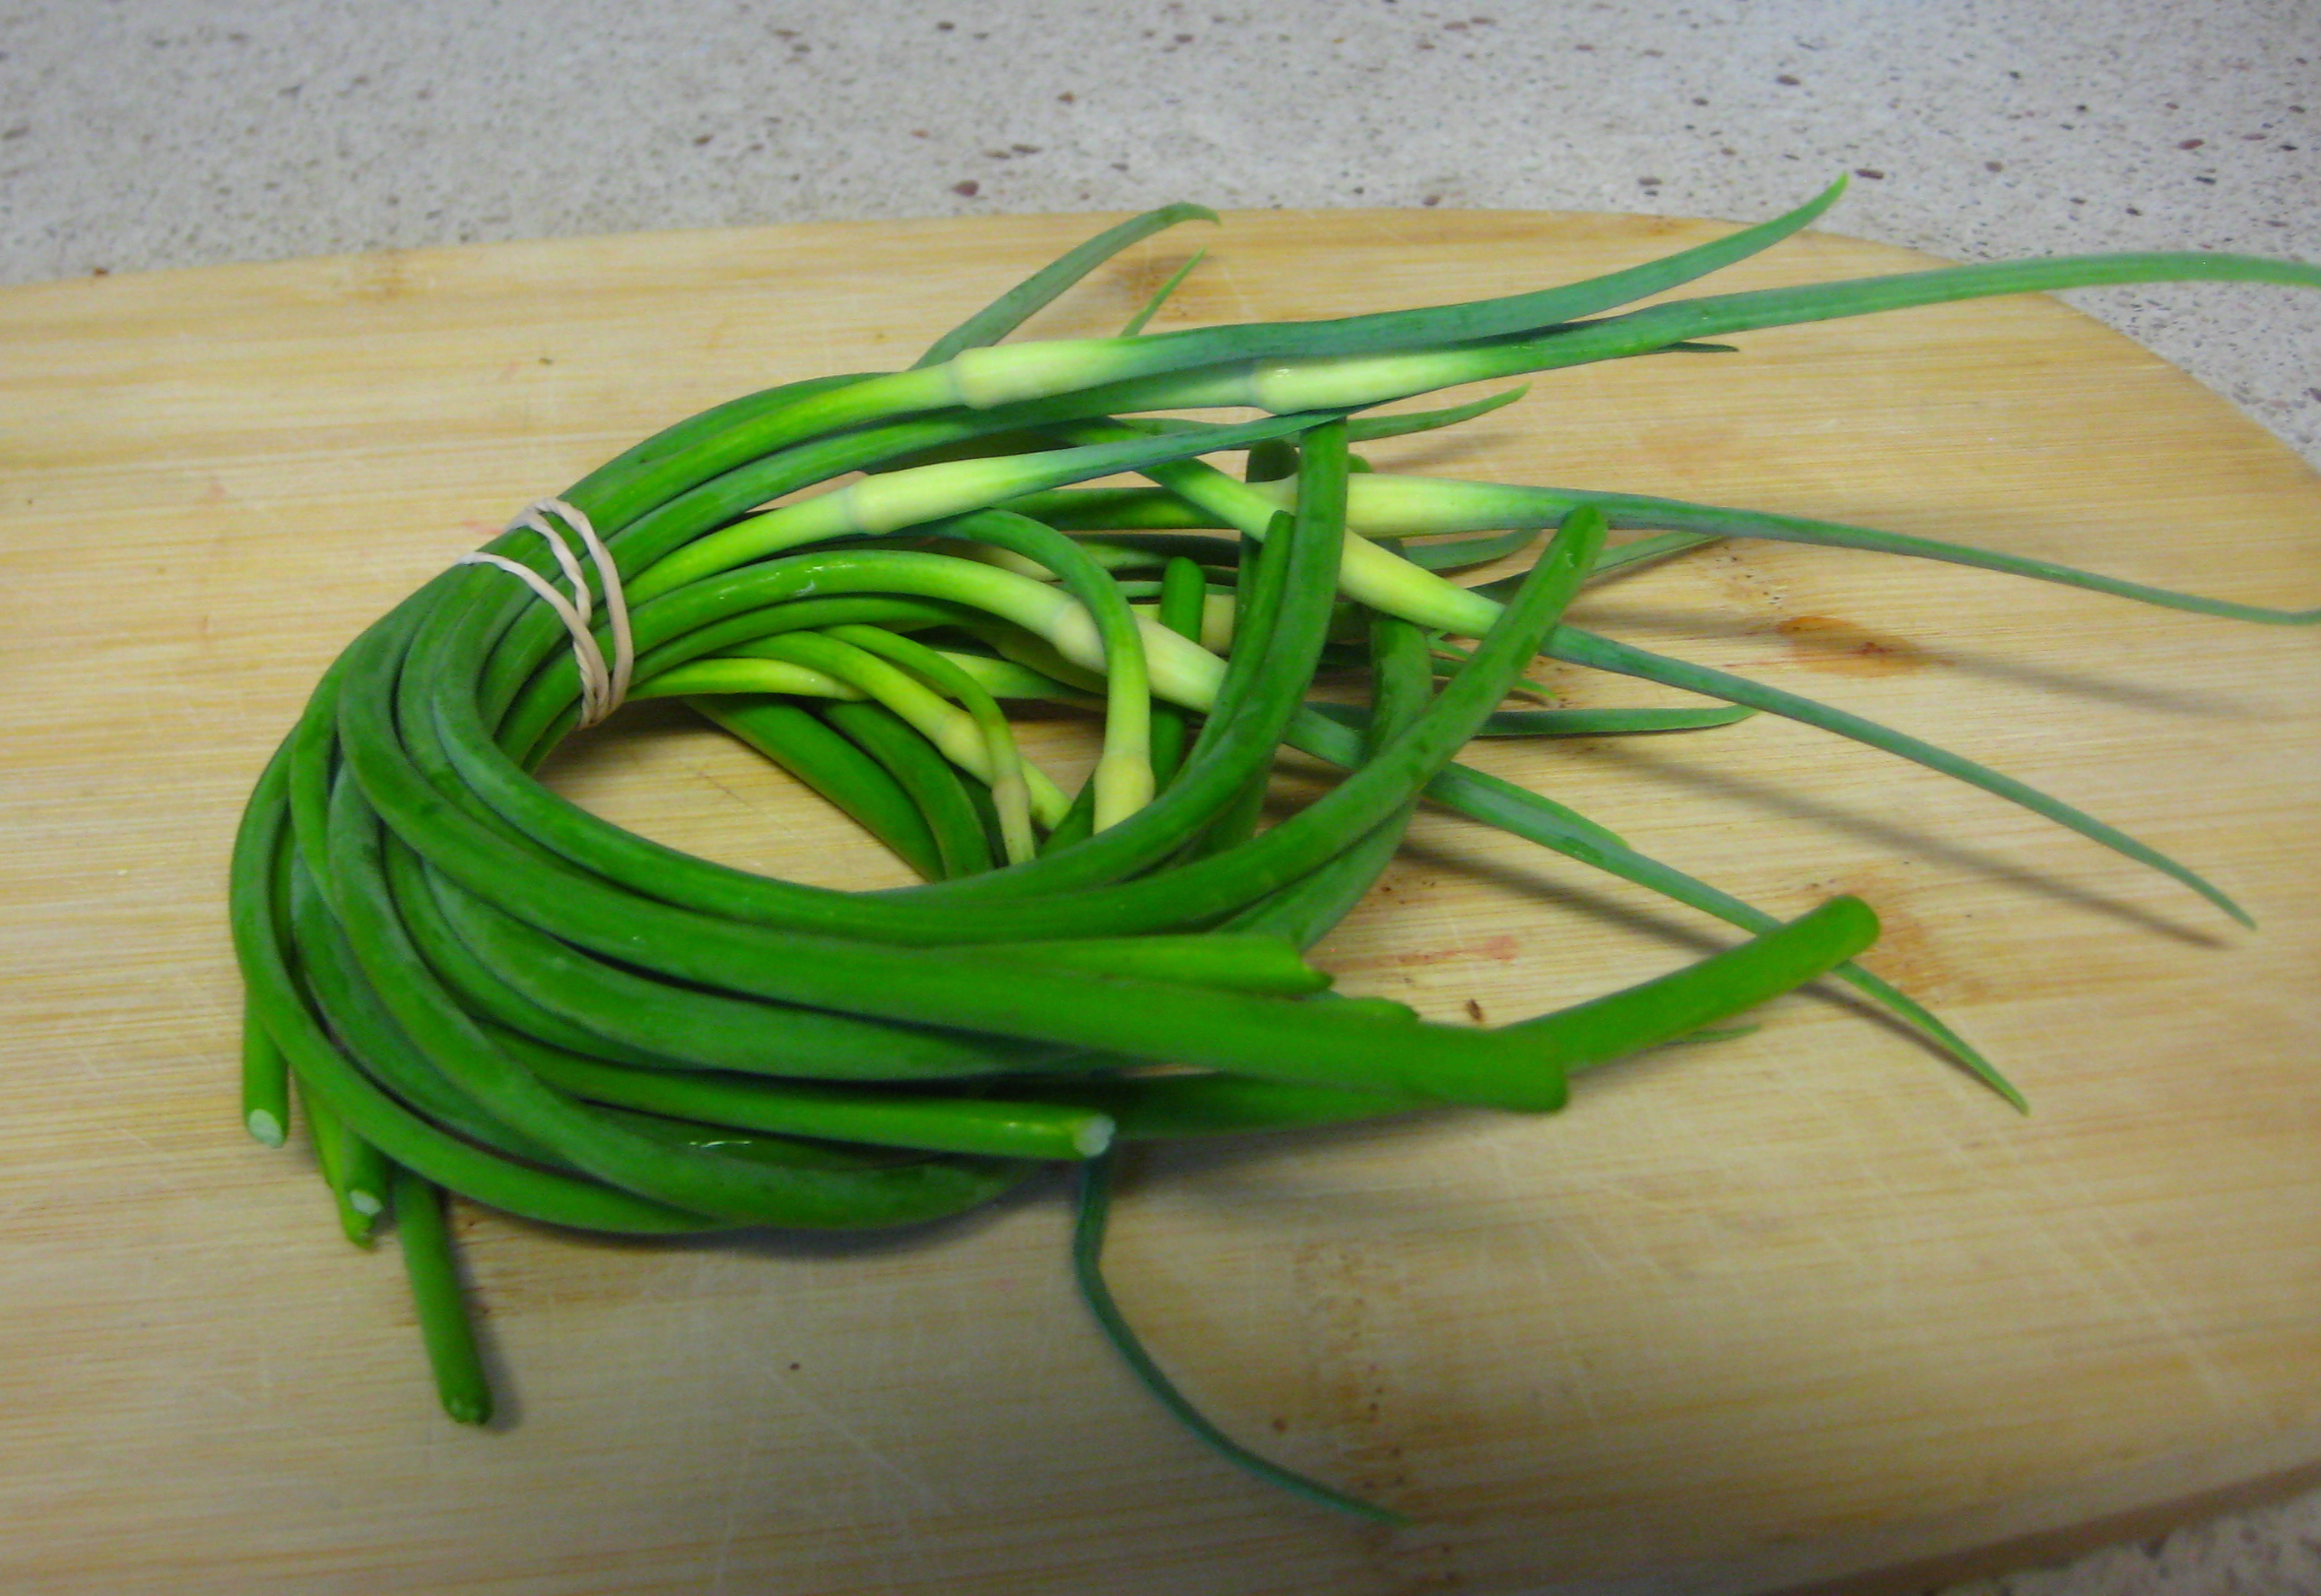 | Use these as you would garlic to add flavor to any dish. | $1.50/bunch
Kale, Lacinato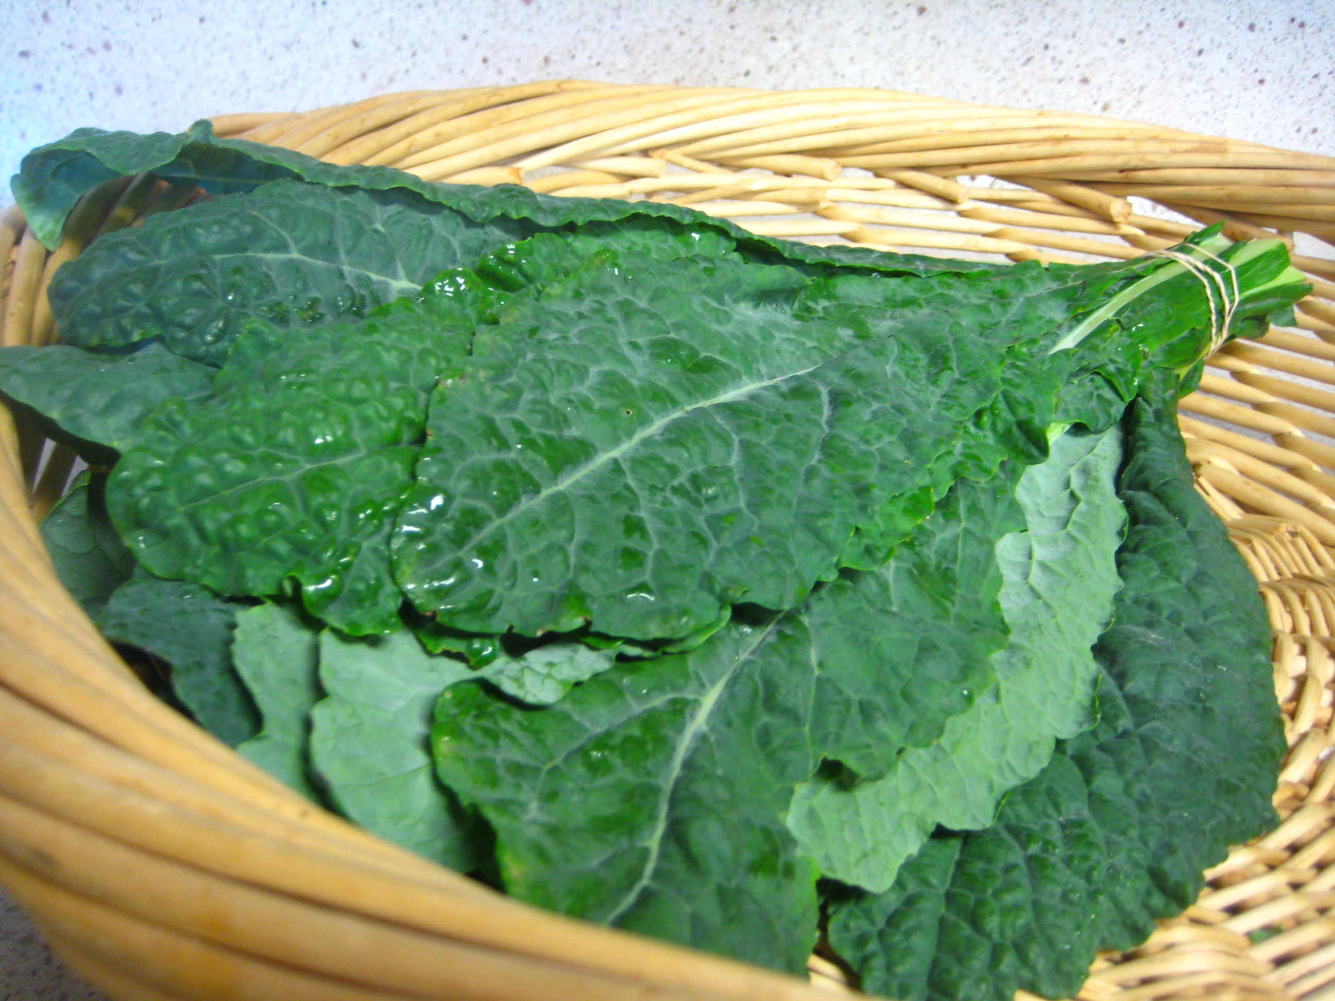 | Blue-green leaves with a heavily savoyed texture and excellent delicious flavor. Also known as dinosaur kale. | $2.50/bunch or 2 for $4.00
Kale, Red Russian | Frilly purple-veined blue-green leaves tinged with reddish-purple. Very tender with a mild sweet flavor. | $2.50/bunch or 2 for $4.00
Kale, Winterbor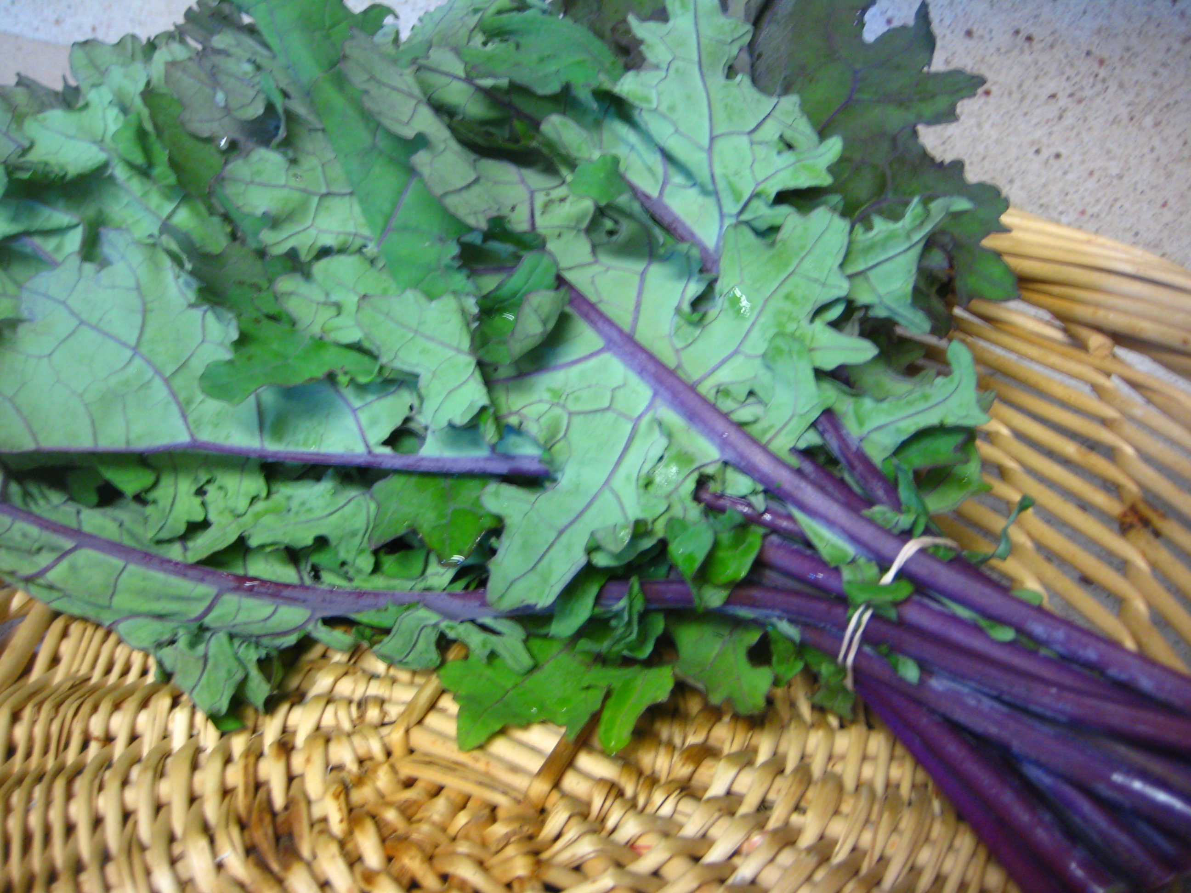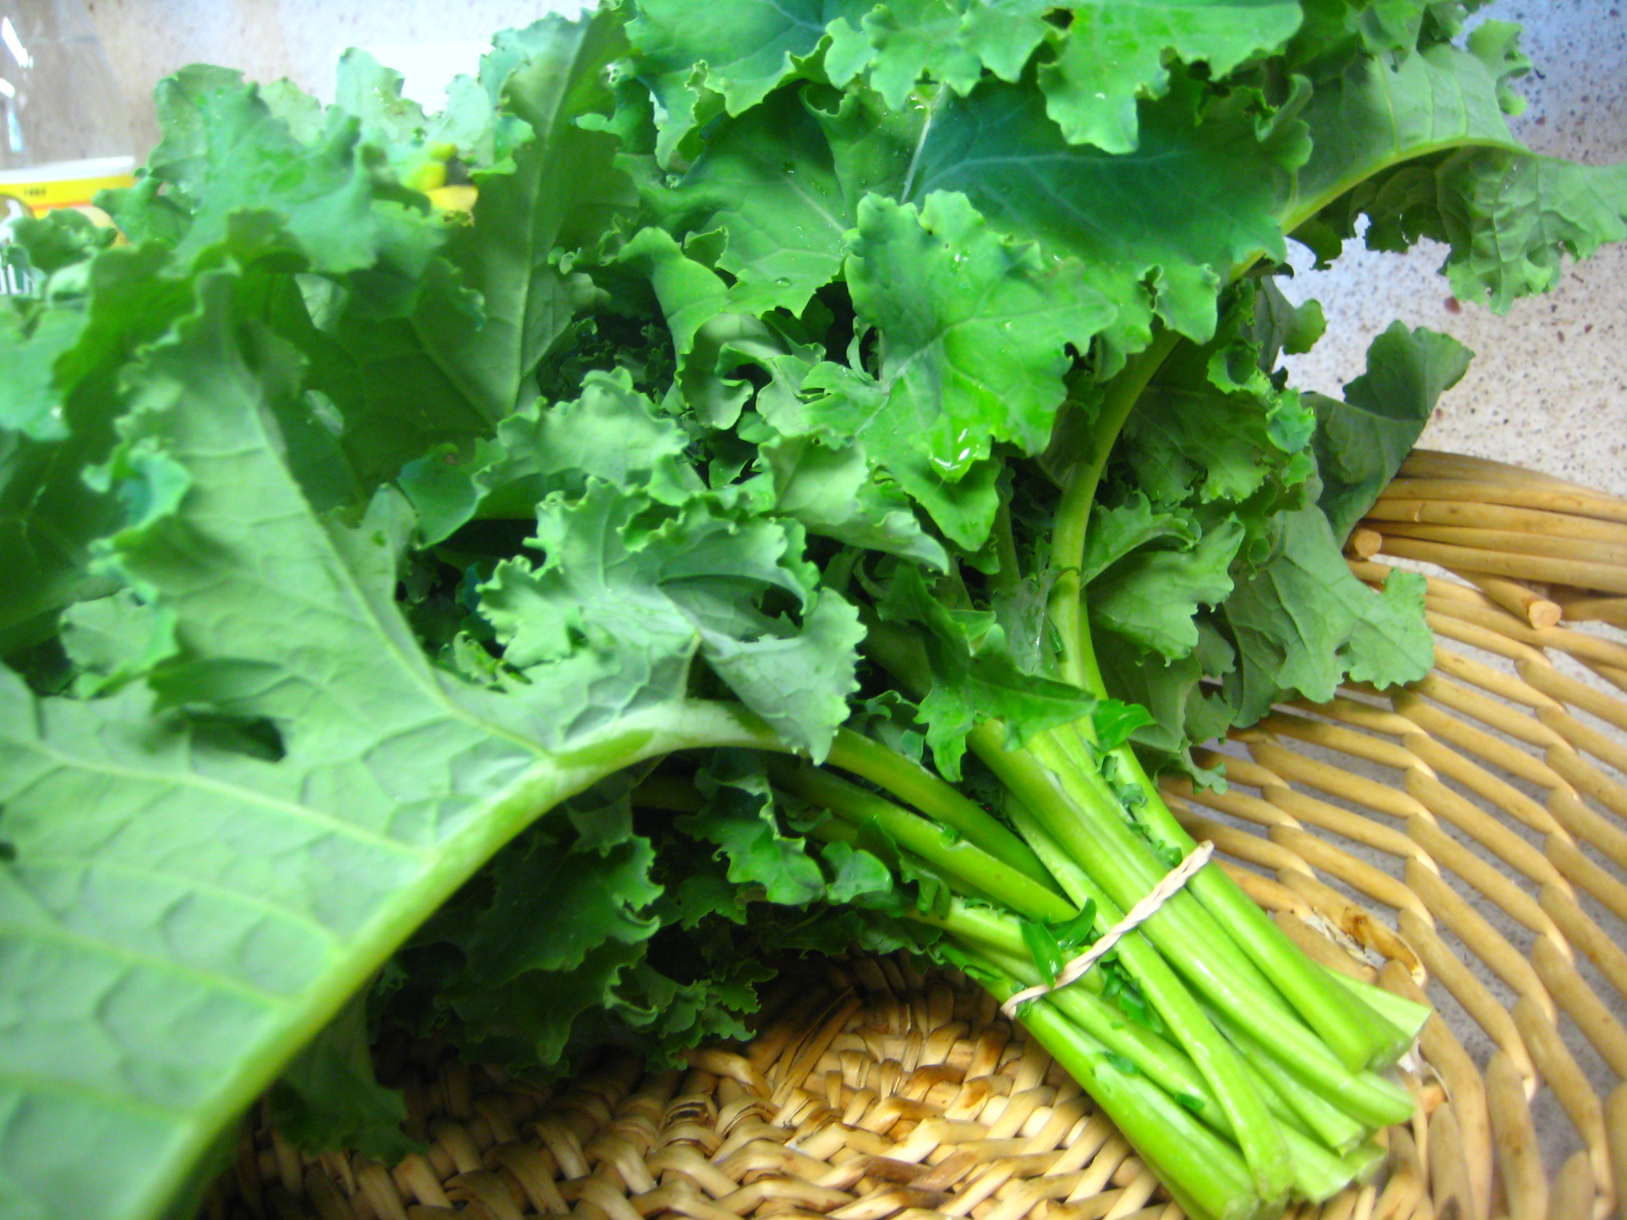 | Finely curled, thick, blue-green leaves good for salad mixes. Sweet and juicy. The classic kale. | $2.50/bunch or 2 for $4.00
Kohlrabi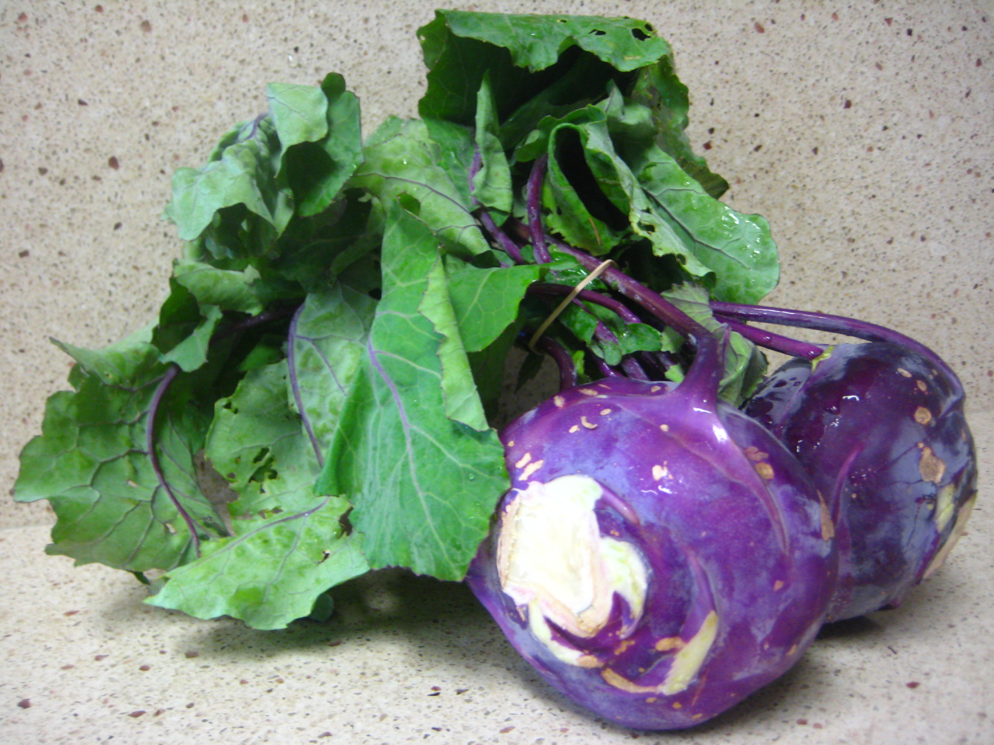 | Crisp, sweet and mildly tangy. Eat it raw with your favorite spread, or try it roasted. | $2.50/bunch
Lemon Balm | Strong lemon-scented leaves are good for making tea or adding a hint of lemon to any dish. | $1.50/bunch
Lettuce, Amish Deer Tongue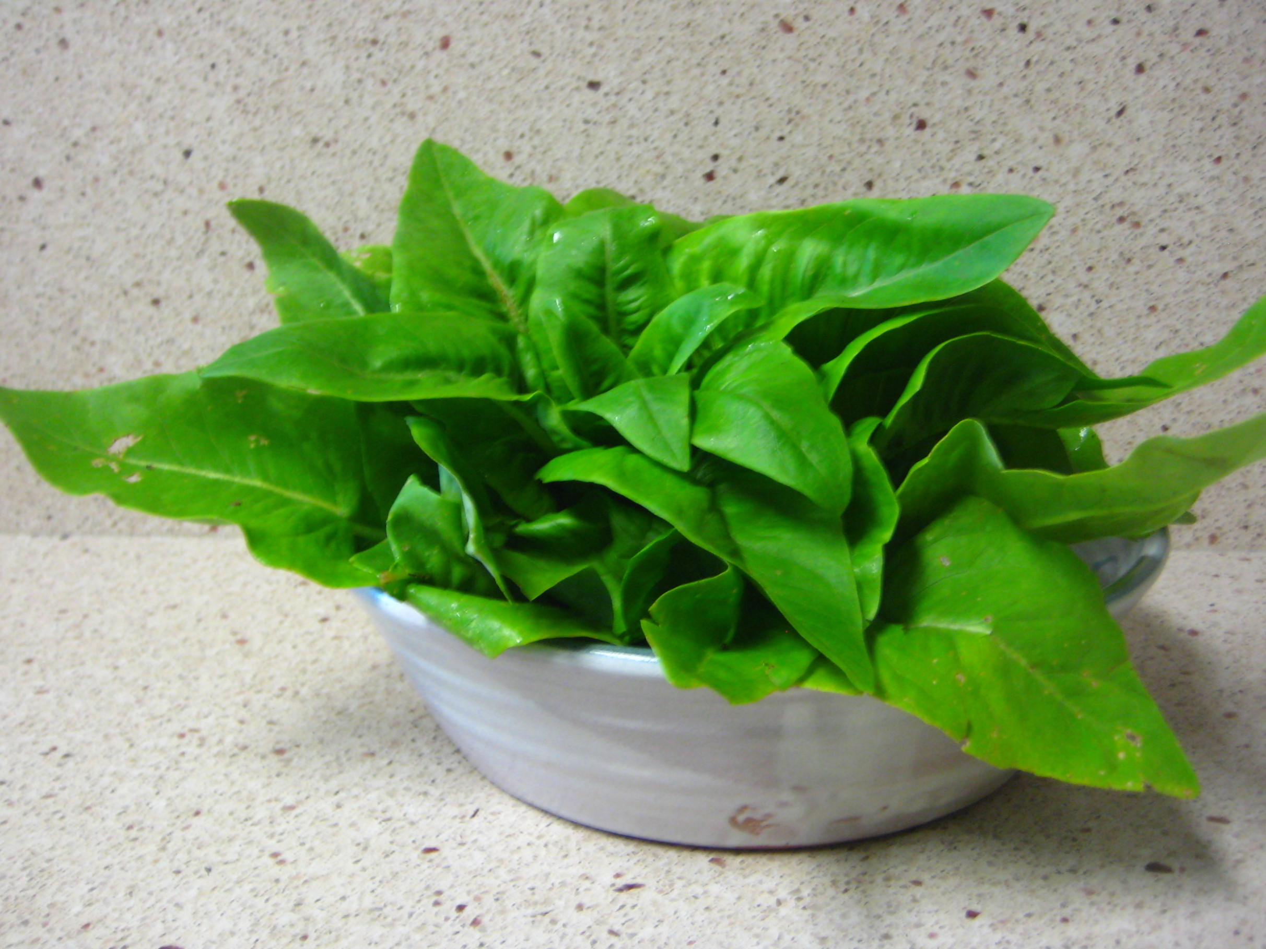 | Sharply triangular green leaves with straight edges and a thin midrib. Has a pleasant, sharp flavor. | $2.00/head
Lettuce, Black Seeded Simpson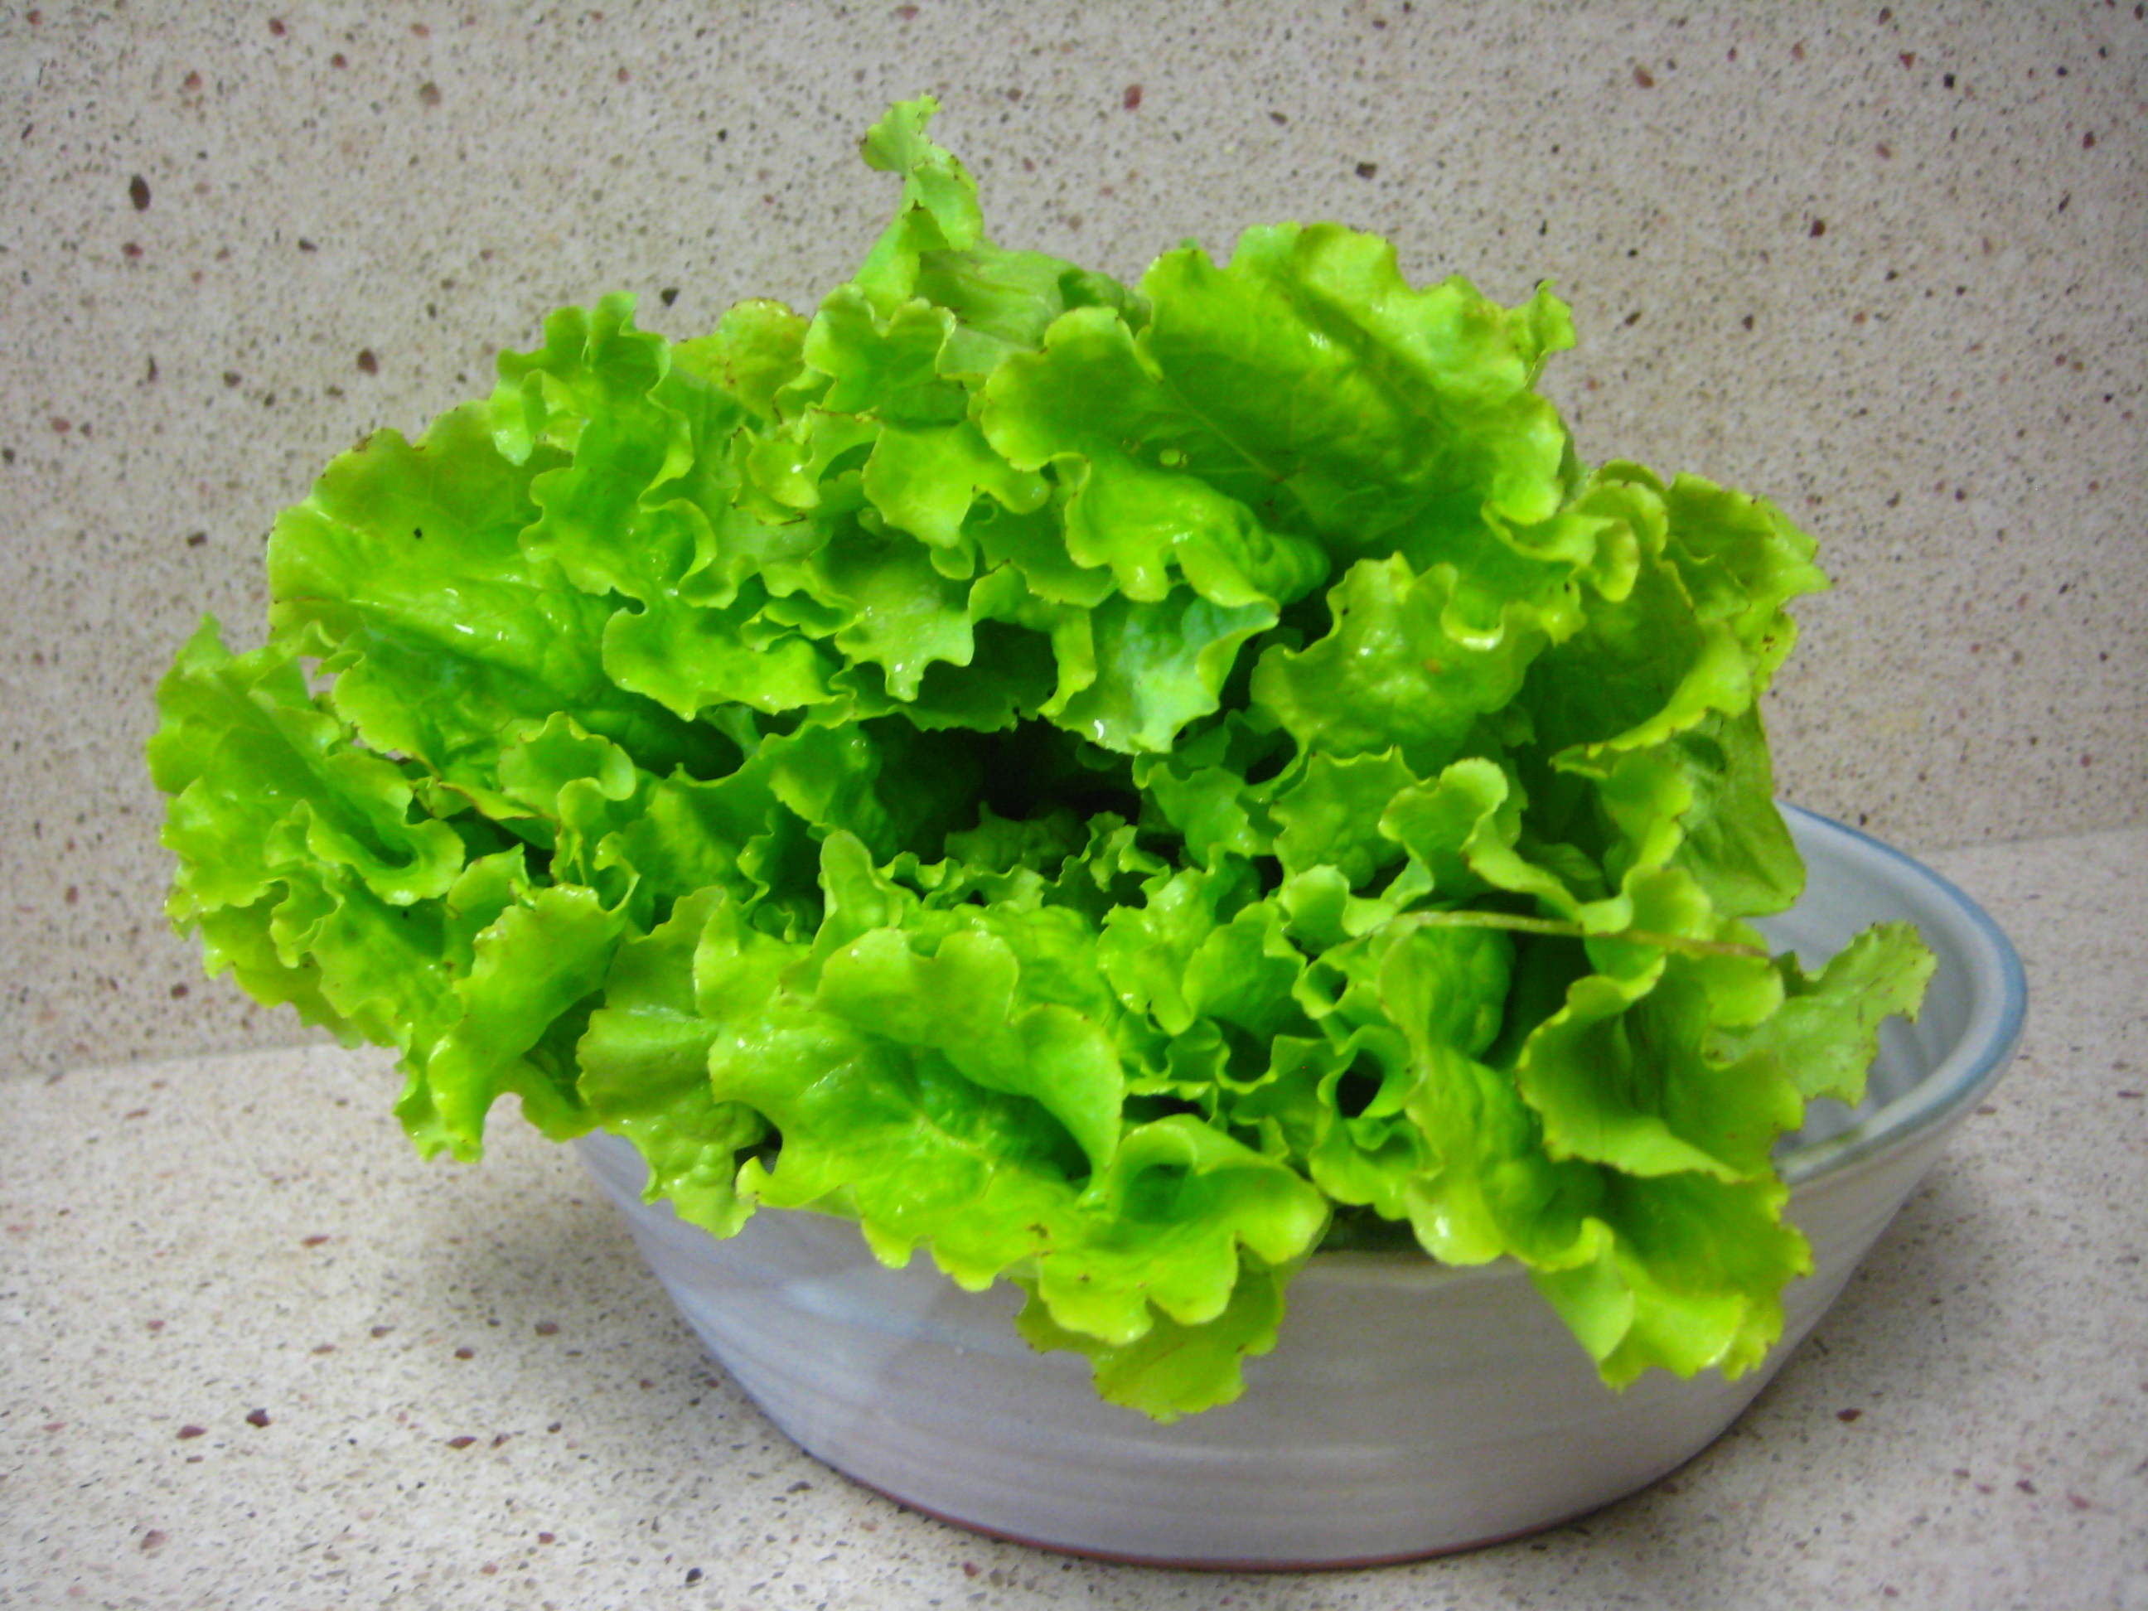 | Crisp, tender, vibrant green leaves are perfect for a salad or sandwich. | $2.00/head
Mint | Aromatic leaves are perfect for a garnish or to use in cooking. | $1.50/bunch
Oregano | This classic pizza herb has fragrant, tender leaves. | $1.50/bunch
Radish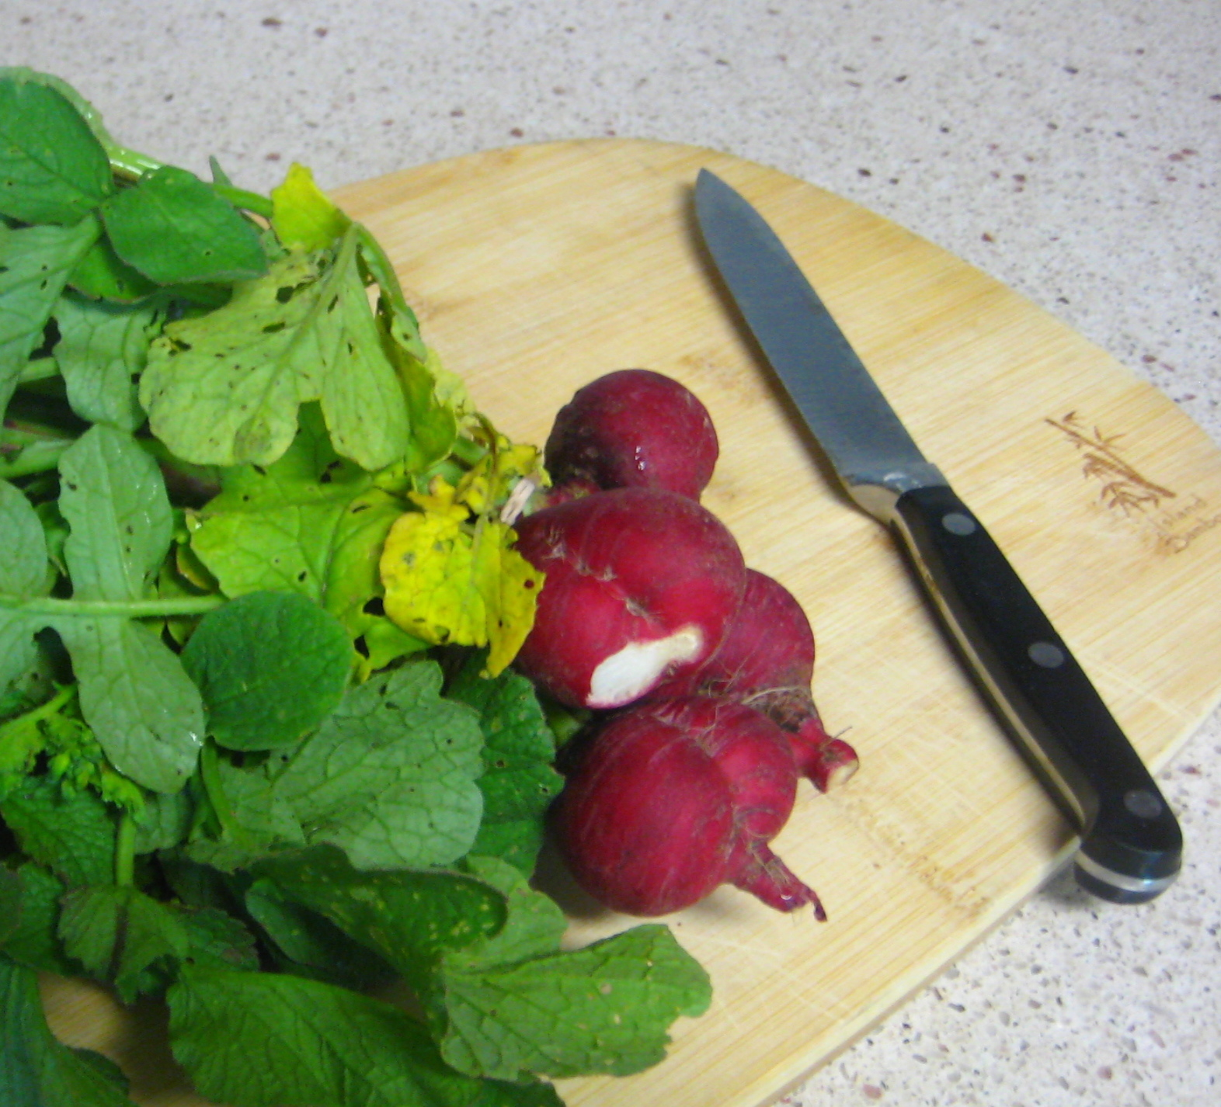 | Bright red skin and white flesh, these bite size radishes have an intense flavor. | $1.00/bunch
Radish, French Breakfast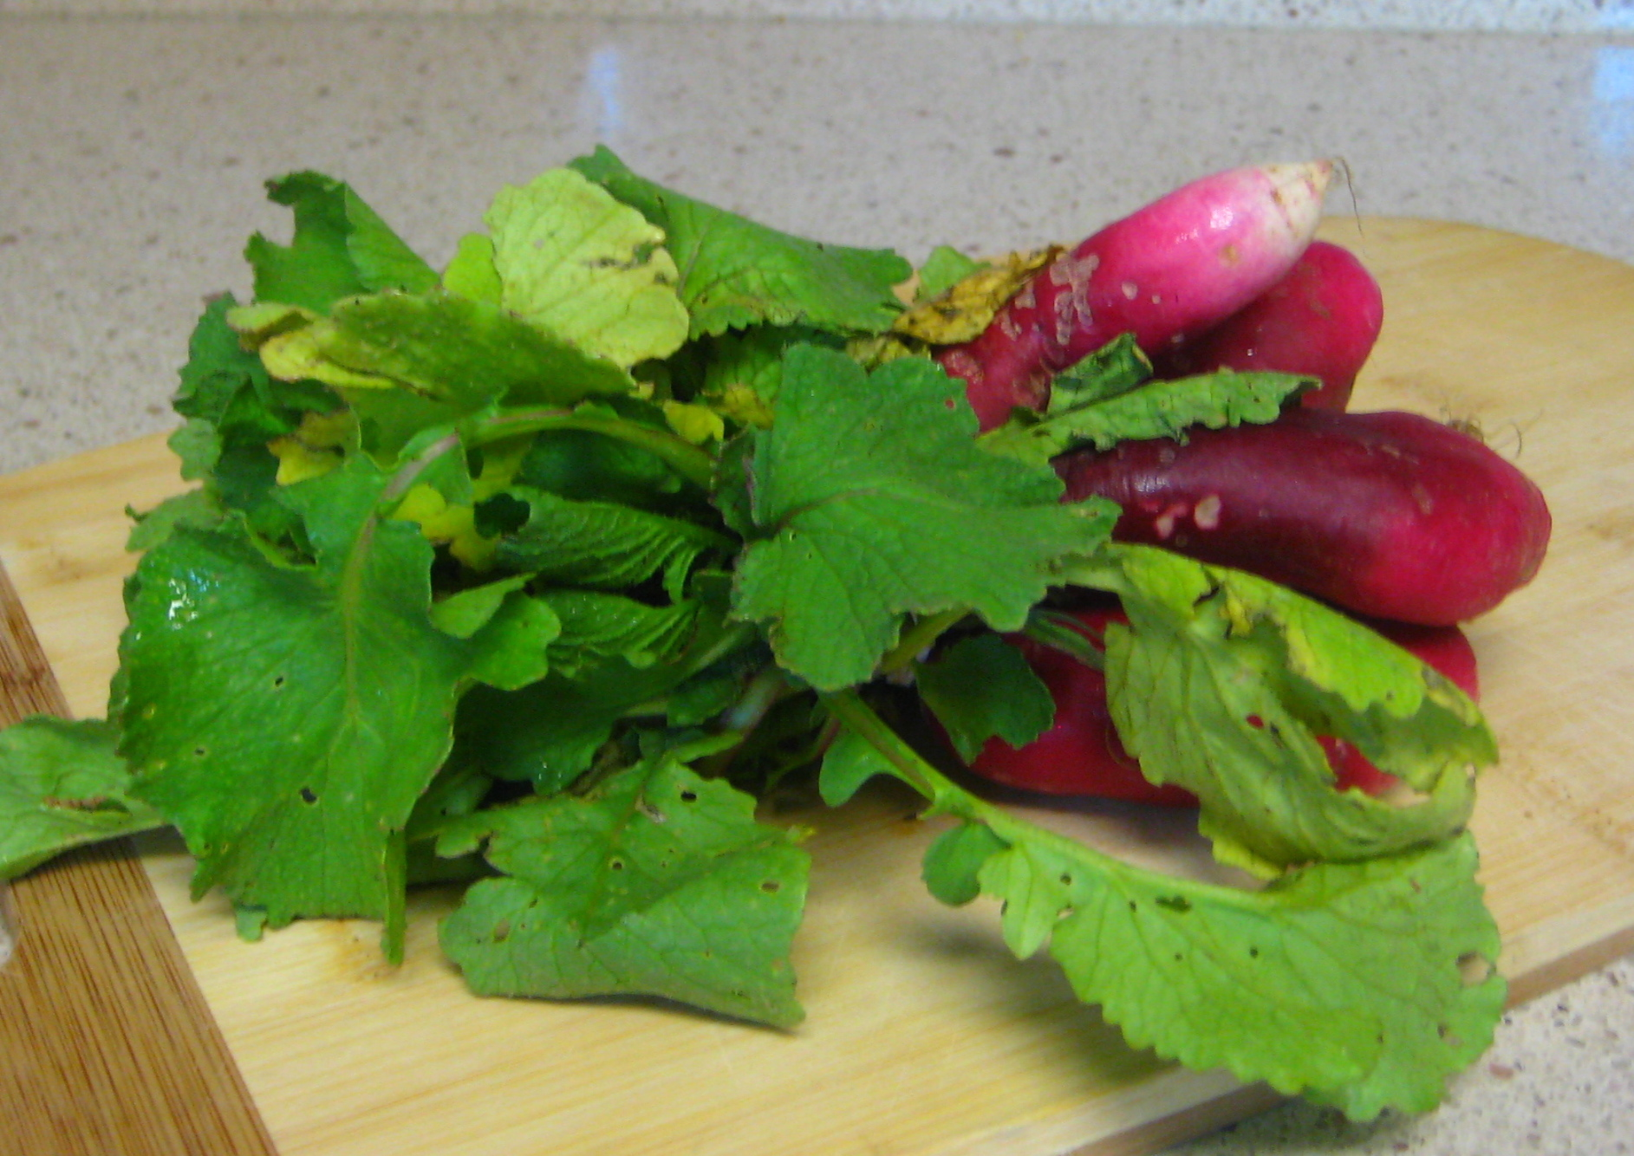 | Oblong and elegant with white, crisp flesh and a mildly pungent flavor. | $1.00/bunch
Sweet Marjoram | Highly esteemed for a variety of seasoning needs. Similar to oregano, but noticeably sweeter. | $1.50/bunch

